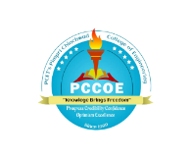 | Pimpri Chinchwad Education Trust's  Pimpri Chinchwad College of Engineering, Pune  An Autonomous Institute  (Affiliated to Savitribai Phule Pune University) |   IIC ID: IC201810343  
World Entrepreneurs Day 2025
(21st September 2025)

Academic year: 2025-26 Date: 22/09/2025
Program Driven by: IIC Calendar Activity/ Self Driven/MIC Driven/Celebration (choose anyone)
Quarter: Semester-1 Quarter-1
Program/Activity Name: World Entrepreneurs Day 2025
Program Type: Level 1: Expert Sessions (Choose any one below)
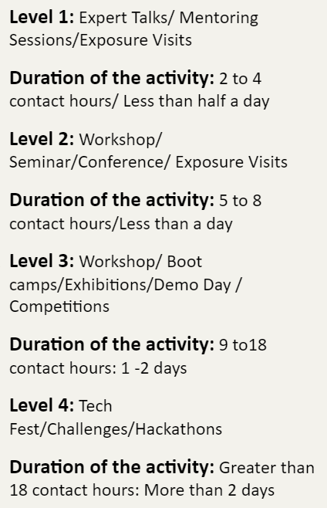
Program Theme: Entrepreneurship and Startup (Choose any one below)
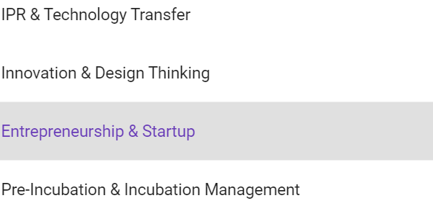
Duration of the activity in Hours: 3 hours
Start date of the event:21/8/2025
End date of the event:21/8/2025
No. of student participants:43 (Minimum 40)
No. of Faculty participants:05
No. of external participants if any: 05
Expenditure amount if any: Rs. 2000/-
Remarks: Event description
Mode of Session delivery: Offline
Objective: (Max. no. of characters=100)
Benefit: (Max. no. of characters=150)
Detailed Description of the event:
- Image of Event Brochure
- Two photographs
- Attendance
- Video url:(optional)
Social Media Links: (Minimum two links are compulsory)
Twitter:
Instagram:
LinkedIn:
Name & Sign of Event coordinators:
Name & Sign of IIC coordinator:

Name & Sign of Head of the Department:

Attachments:
- Phortogragh1 & 2 compulsory :(Size of each photo max. 2MB, preferably GPS tagged photos)
- Overall Report of the activity in pdf format:(Size of each photo max. 2MB)

